**A Project Report**

On

**“ONLINE EVENT BOOKING SYSTEM”**

Submitted to the

Savitribai Phule Pune University

In partial fulfillment for the award of the Degree of

Bachelor of Technology

in

**Information Technology**

By

Umesh Bobade [UIT20M1010]

Sanket Dawange [UIT20M1019 ]

Rahul Jagdhane [UIT20M1030]

Dipjyot Jape [UIT20M1031]

Samarth Kolapkar [UIT20M1034]

1 Rahul Kolase [UIT20M1035]

Ashwini Gidghe [UIT21F2074]

Pradnya Sasane [UIT19F1052]

**T.Y. Information Technology**

Under the guidance of

**Prof. K. D. Patil**

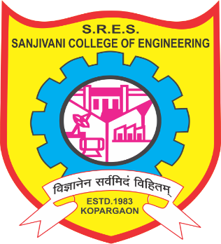

**Department of Information Technology**

**SRES’s Sanjivani College of Engineering, Kopargaon 423603**

**2022-23**

**SRES’s Sanjivani College of Engineering, Kopargaon 423603**

**Department of Information Technology**



**CERTIFICATE**

This is to certify that the project-based report entitled **“Online Event Booking System”** of Skill based Credit Course being submitted by **Group – Agartala (Class: TY (IT) Division: A)** is a record of bonafide work carried out by them under the supervision and guidance of **Prof. K. D. Patil** in partial fulfillment of the requirement for **TY (Information Technology)** of Savitribai Phule Pune University, Pune in the academic year 2022-23.

Date: / /2022

Place: Kopargaon

**Prof. K.D. Patil**  **Prof. Y. S. Deshmukh**   **Dr. M. A. Jawale**

Guide SBCC Coordinator Head of the Department

**Dr. A. G. Thakur**

Director

**ACKNOWLEDGEMENT**

The entire session of skill-based credit course completion phase so far was a great experience providing us with great insight and innovation into learning various technologies and achievement of it. As is rightly said, for the successful completion of any work, people are the most important asset. Our project would not have been materialized without the cooperation of many of the people involved. First and foremost, I am very much thankful to our respected Skill Based Credit Course guide Prof. K. D. Patil, Our Skill Based Credit Course coordinator Prof. Y. S. Deshmukh for their leading guidance and sincere efforts in finalizing and completion of this topic. They took a deep interest in correcting the minor mistakes and guided us through our journey so far. Also, they have been a persistent source of inspiration for me. I am also very thankful of Dr. M. A. Jawale, Head of Dept. of Information Technology Engineering for the symmetric guidance and providing necessary facilities and I Express deep gratitude to all the faculty members and our department’s technical Staff for providing me needed help.

**ABSTRACT**

The purpose of Event Management System is to automate the current manual system by the help of computerized equipment’s and full-fledged computer software, fulfilling their requirements, so that their valuable data/information can be stored for a longer period with easy accessing and manipulation of the same. The required software and hardware are easily available and easy to work with.

Event Management System can lead to error free, secure, reliable and fast management system. It can assist the user in concentrating on their other activities rather to concentrate on the record keeping. Thus, it will help the organization in better utilization of resources. The organization can maintain computerized records without redundant entries. That means that one need not be distracted by information that is not relevant, while being able to reach the information.

The aim is to automate its existing manual system by the help of computerized equipment and full-fledged computer software, fulfilling their requirements, so that their valuable data/information can be stored for a longer period with easy accessing and manipulation of the same. Basically the project describes how to manage good performance and better services for the clients.

**CONTENT**

|  |  |  |
| --- | --- | --- |
| Sr. | Chapters | Page |
| 1 | Chapter 1- Problem Definition | 6 |
| 2 | Chapter 2- Literature Survey | 7 |
| 3 | Chapter 3- Diagram  1] Site Map  2] Wire Frames | 8 |
| 4 | Chapter 4- Methodology | 9 |
| 5 | Chapter 5- Implantation | 13 |
| 6 | Chapter 6- Conclusion | 20 |
| 7 | Chapter 7- Reference | 21 |

**Chapter 1: Problem Definition**

**Problem**- Every Organization, whether big or small, has challenges to overcome and managing every event.

**Solution**- Management System has different event needs, so we design an exclusive Event Management System. This is designed to assist in strategic planning, and it will help to ensure that your organization is equipped with the right level of information and details of your future goals. Also, for those busy executive who are always on the go, our system come with remote access features, which will allow you to manage your workforce anytime. This system will ultimately allow you to better manage resources.

**Chapter 2**: **Literature Survey**

Book passes for events but cannot register as participants. Neither it is going to do great good for organizers of events. In the existing system participants must run to offices to enquire about the required events. The existing system is quite complex and manual one. Moreover, the Event Manager gets involved in lot of paper works and keeping records manually. As an event organizer we have been observing events closely to gather requirements and problems faced by event managers. Companies like Cvent do business in projects related to event management and have a pretty good income in it. Many aspirants of IT and CSE dream of working in it.

In brief existing physical system has following drawbacks:

• Paperwork done manually requires a lot of time and is laborious.

• Maintaining records is difficult in log run for any use in future.

• It is not safe to handle huge transactions. Mistakes in calculations can ruin the hard work.

• Huge manpower is required before even executing event on ground We came across it as we were once organizing a hackathon in our campus and were manager there.

We came across several problems in it. Most of the students even complained that they hadn’t come to know about the competition. Also, we were not able to communicate with many participants as it was manually due to which many last-minute problems arose in our event. After all this we decided to take it up as our project and try to inculcate several features to ease the work of such managers.

**Chapter 3: Diagrams**

**1. Site Map**

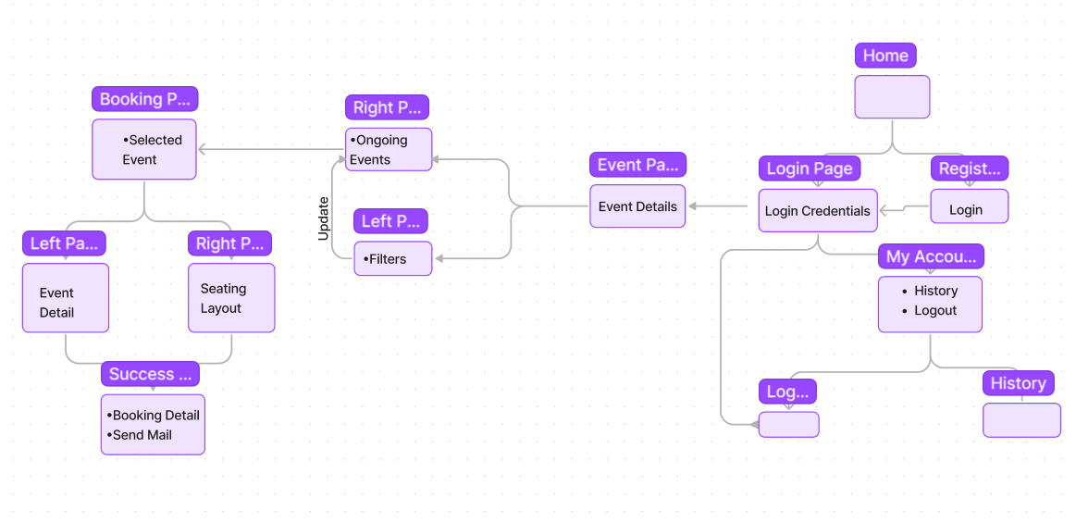

Fig. 3.1 Site Map

**2. Wire Frame**

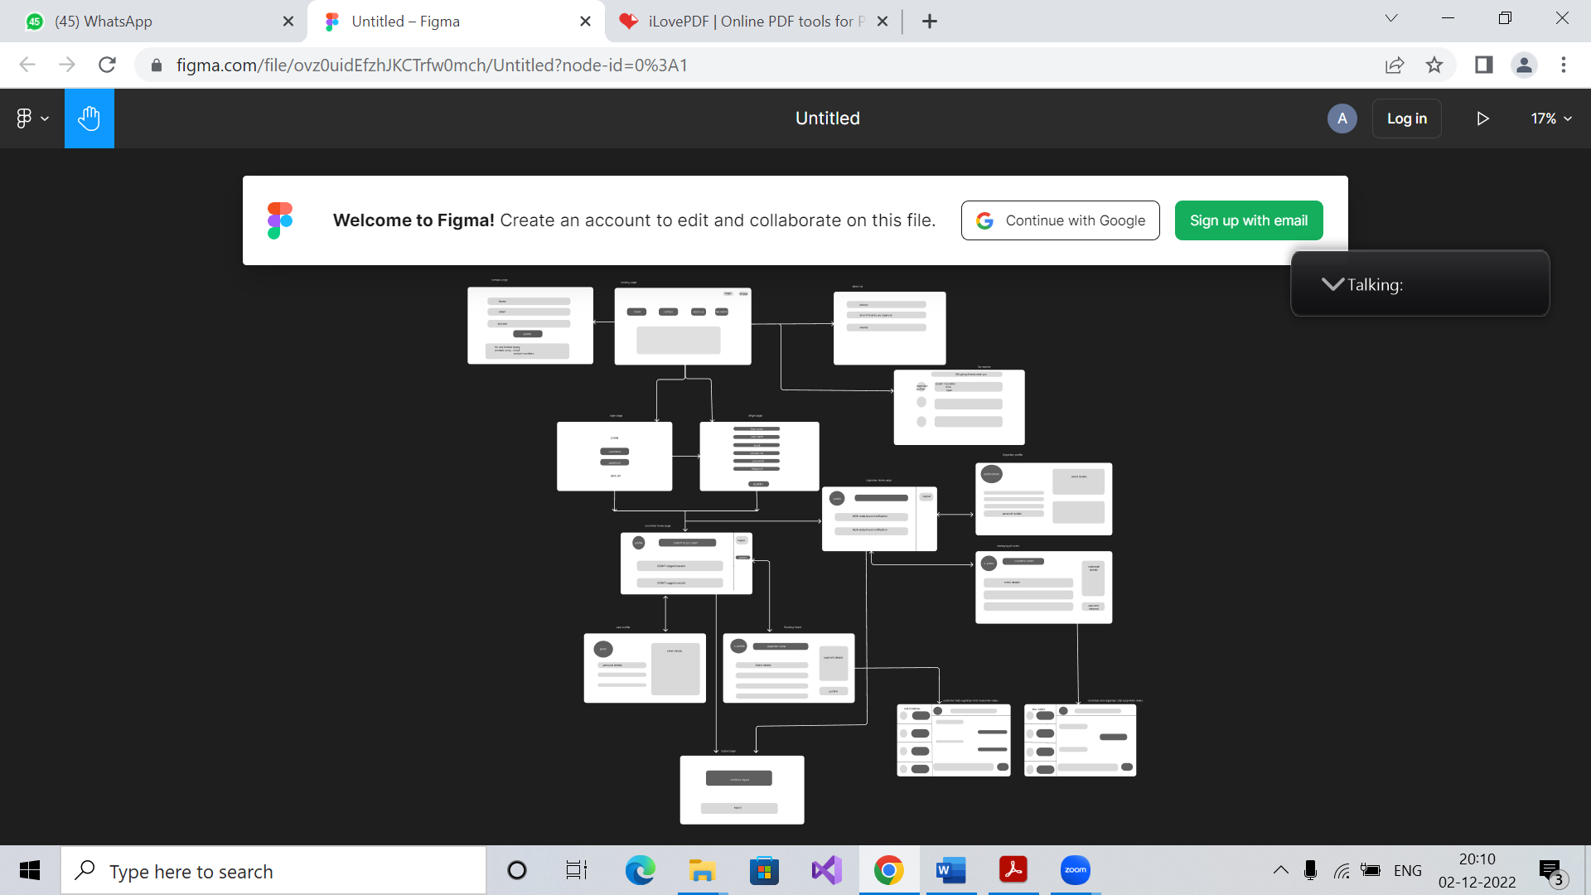

Fig. 3.2 Wire Frame

**Chapter 4: Methodologies**

### Agile Software Development

Agile is a type of software development methodology that anticipates the need for flexibility and applies a level of pragmatism to the delivery of the finished product. Benefits of Agile include its ability to help teams in an evolving landscape while maintaining a focus on the efficient delivery of business value. The collaborative culture facilitated by Agile also improves efficiency throughout the organization as teams work together and understand their specific roles in the process.

The Agile Manifesto also outlined 12 core principles for the development process. They are as follows:

1. Satisfy customers through early and [continuous delivery](https://www.techtarget.com/searchitoperations/definition/continuous-delivery-CD) of valuable work.
2. Break big work down into smaller tasks that can be completed quickly.
3. Recognize that the best work emerges from self-organized teams.
4. Provide motivated individuals with the environment and support they need and trust them to get the job done.
5. Create processes that promote sustainable efforts.
6. Maintain a constant pace for completed work.
7. Welcome changing requirements, even late in a project.
8. Assemble the project team and business owners daily throughout the project.
9. Have the team reflect at regular intervals on how to become more effective, then tune and adjust behavior accordingly.
10. Measure progress by the amount of completed work.
11. Continually seek excellence.
12. Harness change for a competitive advantage.

### The Agile software development cycle

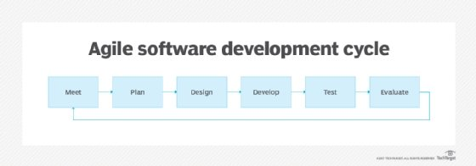

Fig. 4.1 Agile S/W Development Cycle

**Technologies**

**1. HTML**

HTML (**H**yper Text Markup Language) is the code that is used to structure a web page and its content. For example, content could be structured within a set of paragraphs, a list of bulleted points, or using images and data tables. As the title suggests, this article will give you a basic understanding of HTML and its functions. HTML is a markup language that defines the structure of your content. HTML consists of a series of [elements](https://developer.mozilla.org/en-US/docs/Glossary/Element), which you use to enclose, or wrap, different parts of the content to make it appear a certain way, or act a certain way. The enclosing [tags](https://developer.mozilla.org/en-US/docs/Glossary/Tag) can make a word or image hyperlink to somewhere else, can italicize words, can make the font bigger or smaller, and so on.

**2. CSS**

**Cascading Style Sheets (CSS)** is a [stylesheet](https://developer.mozilla.org/en-US/docs/Web/API/StyleSheet) language used to describe the presentation of a document written in [HTML](https://developer.mozilla.org/en-US/docs/Web/HTML) or [XML](https://developer.mozilla.org/en-US/docs/Web/XML/XML_introduction) .CSS describes how elements should be rendered on screen, on paper, in speech, or on other media. [CSS](https://www.w3.org/Style/CSS/) is the language for describing the presentation of Web pages, including colours, layout, and fonts. It allows one to adapt the presentation to different types of devices, such as large screens, small screens, or printers. CSS is independent of HTML and can be used with any XML-based markup language. The separation of HTML from CSS makes it easier to maintain sites, share style sheets across pages, and tailor pages to different environments. This is referred to as the separation of structure (or: content) from presentation.

# **3. JavaScript**

# [JavaScript](https://www.lighthouselabs.ca/en/intro-front-end-developer-course-javascript) is used by programmers across the world to create dynamic and interactive web content like applications and browsers. JavaScript is so popular that it's the most used programming language in the world, used as a client-side programming language by [97.0% of all websites](https://w3techs.com/technologies/details/cp-javascript). Client-side languages are those whose action takes place on the user's computer, rather than on the server.

# JavaScript is versatile enough to be used for a variety of different applications, like software, hardware controls, and servers. JavaScript is most known for being a web-based language, because it's native to the web browser. The web browser can naturally understand the language, like how a native English speaker can naturally understand English.

# JavaScript allows developers to implement features like:

# Showing and hiding menus or information

# Adding hover effects

# Creating image galleries in a carousel format

# Zooming in or zooming out on an image

# Playing audio or video on a web page

# Adding animations

# Creating drop down and hamburger-style menus

**4. Django:**

Django is a high-level Python web framework that enables rapid development of secure and maintainable websites. Built by experienced developers, Django takes care of much of the hassle of web development, so you can focus on writing your app without needing to reinvent the wheel. It is free and open source, has a thriving and active community, great documentation, and many options for free and paid-for support.

Django helps you write software that is:

1. Complete

Django follows the "Batteries included" philosophy and provides almost everything developers might want to do "out of the box". Because everything you need is part of the one "product", it all works seamlessly together, follows consistent design principles, and has extensive and [up-to-date documentation](https://docs.djangoproject.com/en/stable/).

1. Versatile

Django can be (and has been) used to build almost any type of website from content management systems and wikis, through to social networks and news sites. It can work with any client-side framework and can deliver content in almost any format (including HTML, RSS feeds, JSON, and XML).

1. Secure

Django helps developers avoid many common security mistakes by providing a framework that has been engineered to "do the right things" to protect the website automatically. For example, Django provides a secure way to manage user accounts and passwords, avoiding common mistakes like putting session information in cookies where it is vulnerable (instead cookies just contain a key, and the actual data is stored in the database) or directly storing passwords rather than a password hash.

1. Scalable

Django uses a component-based "[shared-nothing](https://en.wikipedia.org/wiki/Shared_nothing_architecture)" architecture (each part of the architecture is independent of the others, and can hence be replaced or changed if needed). Having a clear separation between the different parts means that it can scale for increased traffic by adding hardware at any level: caching servers, database servers, or application servers. Some of the busiest sites have successfully scaled Django to meet their demands (e.g. Instagram and Disqus).

1. Maintainable

Django code is written using design principles and patterns that encourage the creation of maintainable and reusable code. It makes use of the Don't Repeat Yourself (DRY) principle so there is no unnecessary duplication, reducing the amount of code. Django also promotes the grouping of related functionality into reusable "applications" and, at a lower level, groups related code into modules (along the lines of the [Model View Controller (MVC)](https://developer.mozilla.org/en-US/docs/Glossary/MVC) pattern).

1. Portable

Django is written in Python, which runs on many platforms. That means that you are not tied to any particular server platform and can run your applications on many flavors of Linux, Windows, and macOS. Furthermore, Django is well-supported by many web hosting providers, who often provide specific infrastructure and documentation for hosting Django sites.

**5. DB SQLite:**

SQLite is an embedded, server-less relational [database management](https://www.simplilearn.com/what-is-database-management-article) system. It is an in-memory open-source library with zero configuration and does not require any installation. Also, it is very convenient as it’s less than 500kb in size, which is significantly lesser than other database management systems.

|  |  |  |
| --- | --- | --- |
|  |  |  |

**Chapter 5: Implementation**

**1.Home Page**

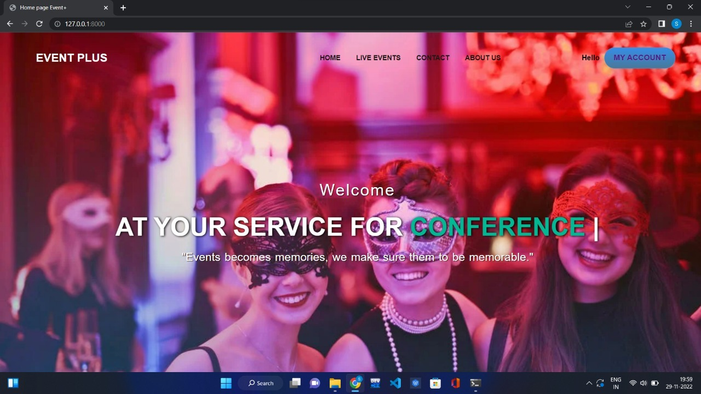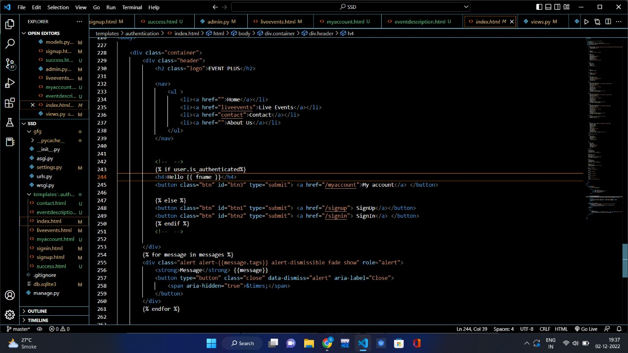

Fig. 5.2 Home Page

Fig. 5.1 Home Page(Source Code)

**2. Login Page**

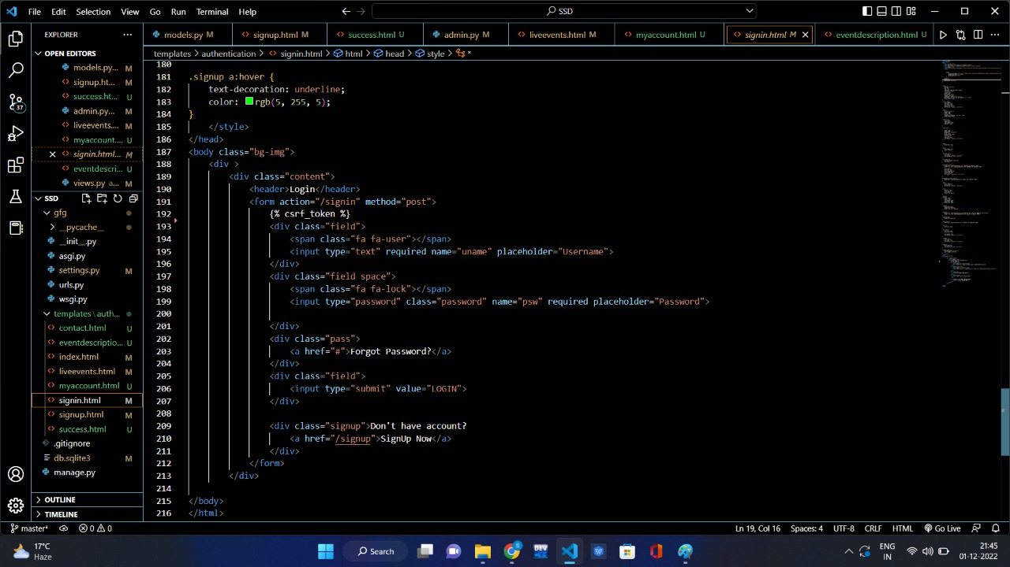

Fig. 5.3 Login Page (Source Code)

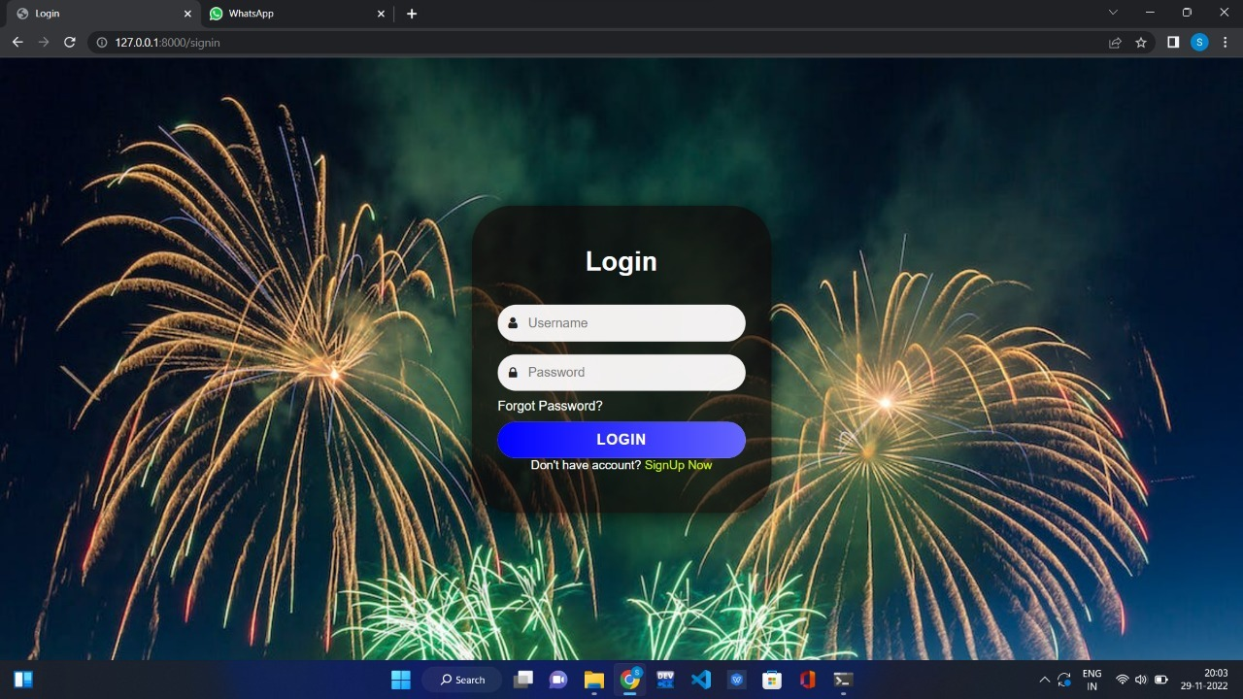

Fig. 5.4 Login Page

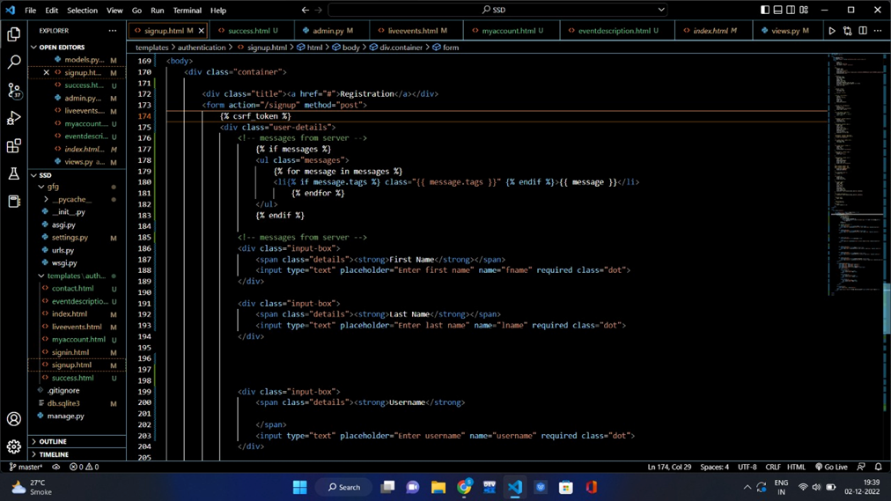**3. Registration Page**

Fig. 5.5 Registration Page (Source Code)

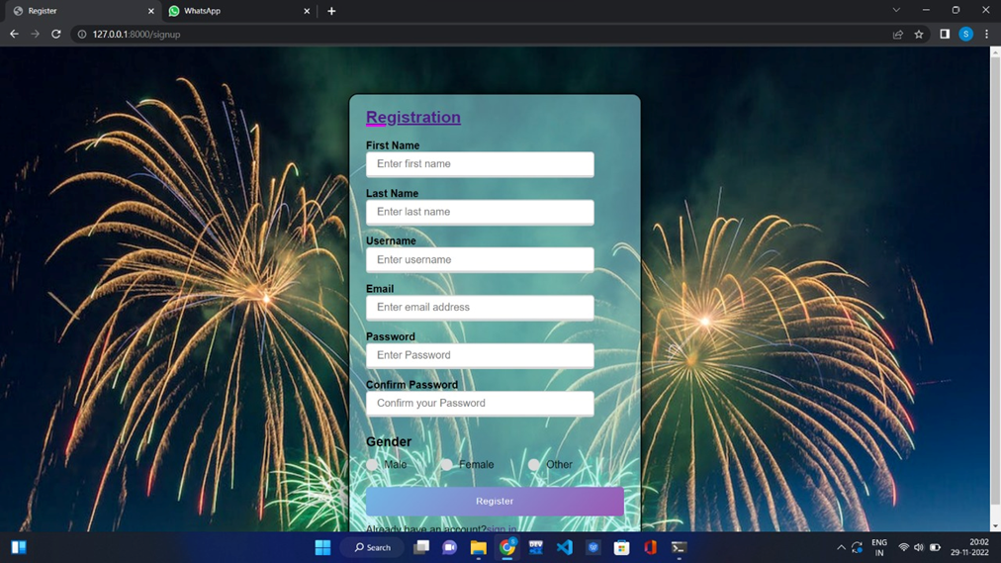

Fig. 5.6 Registration Page

**4. Account Page**

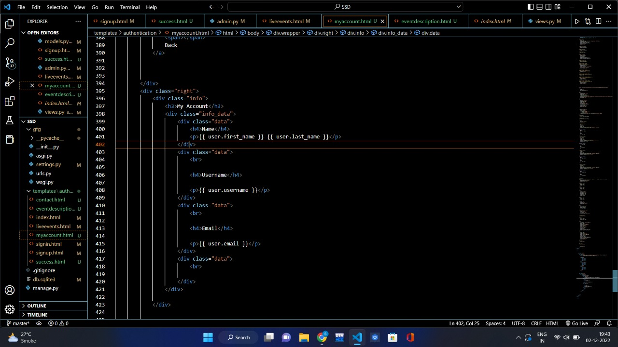

Fig. 5.7 Account Page (Source Code)

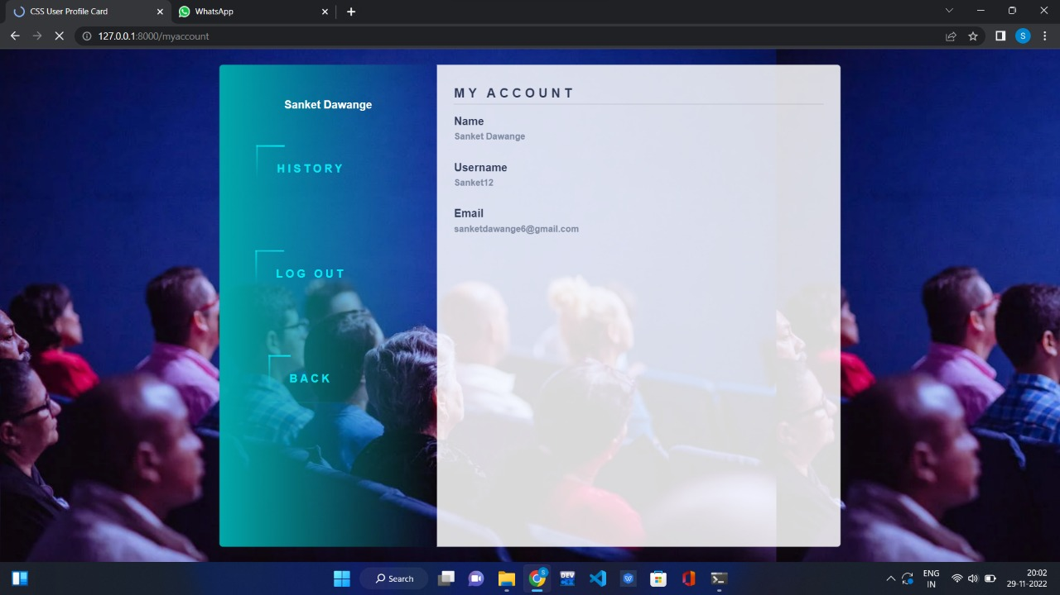

Fig. 5.8 Account Page

**5. Event Page**

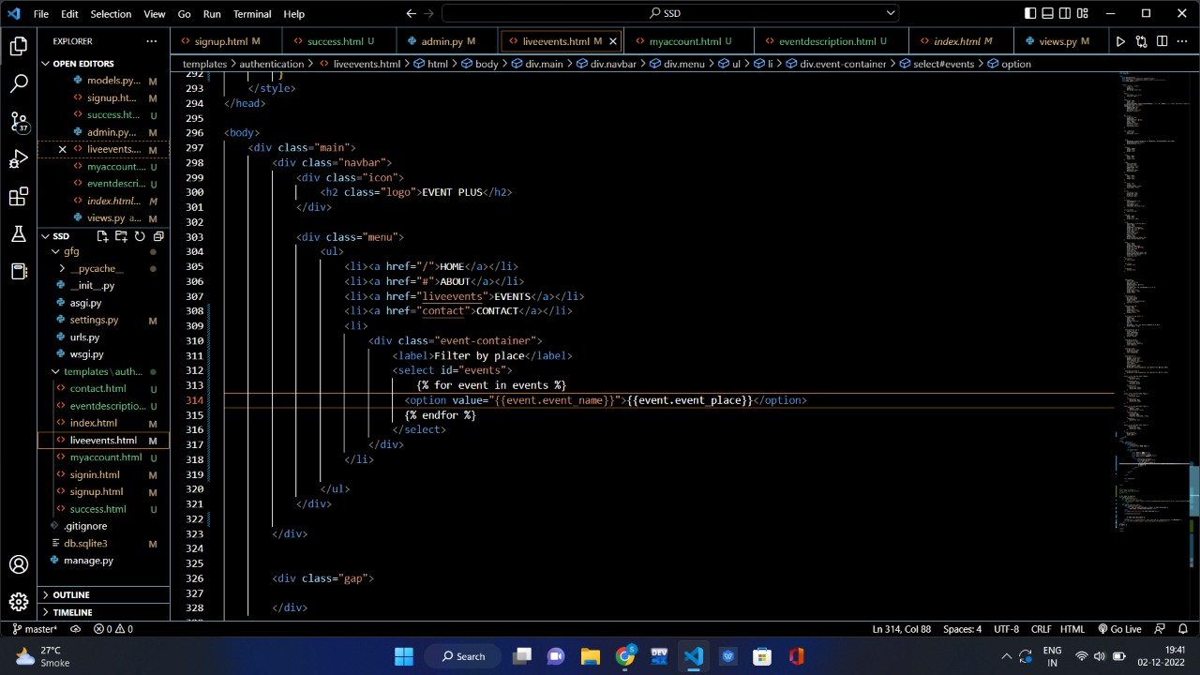

Fig. 5.9 Event Page (Source Code)

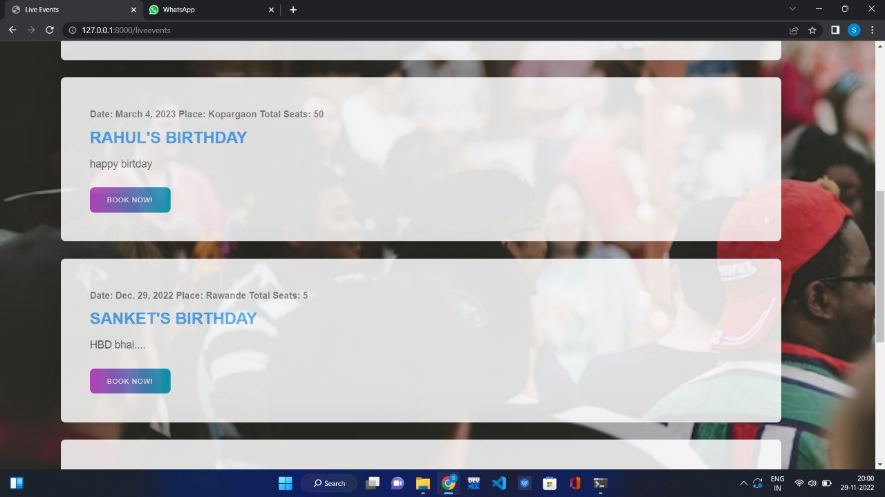

Fig. 5.10 Event Page

**6. Seat Booking**

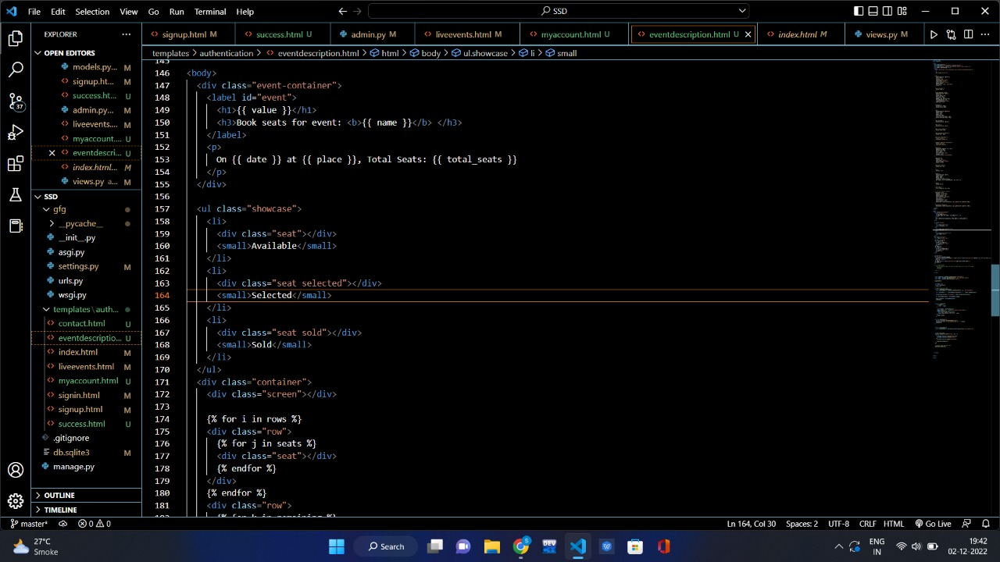

Fig. 5.11 Booking Page (Source Code)

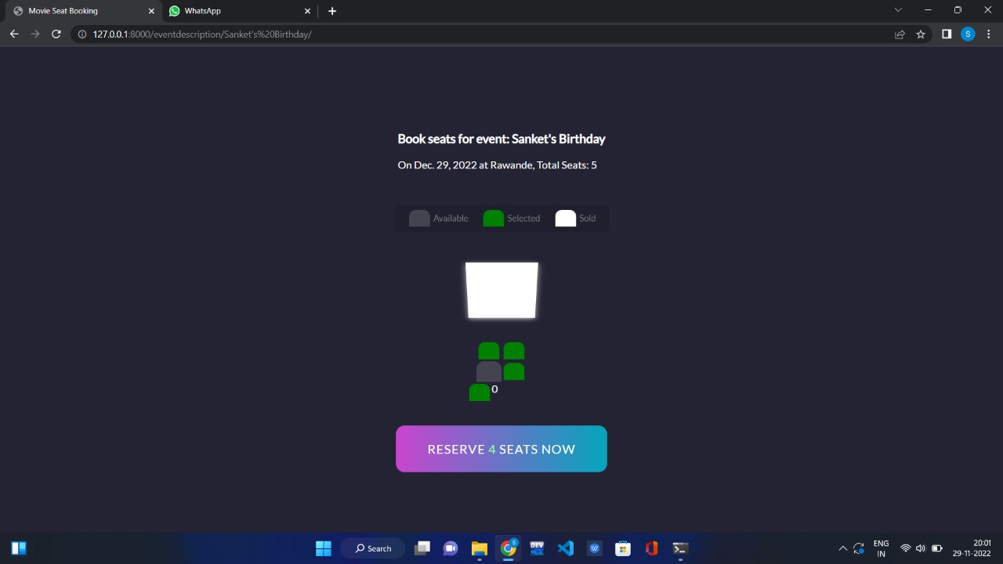

Fig. 5.12 Booking Page

**7. Final Page**

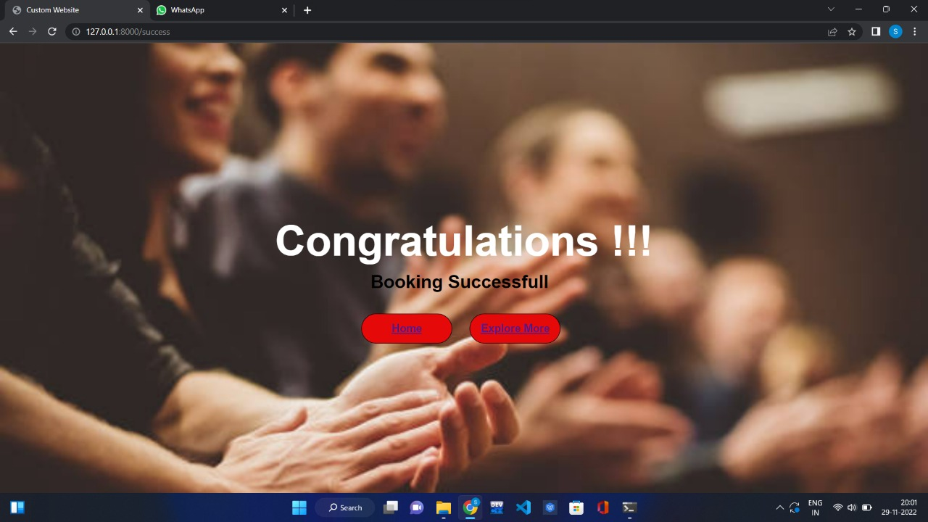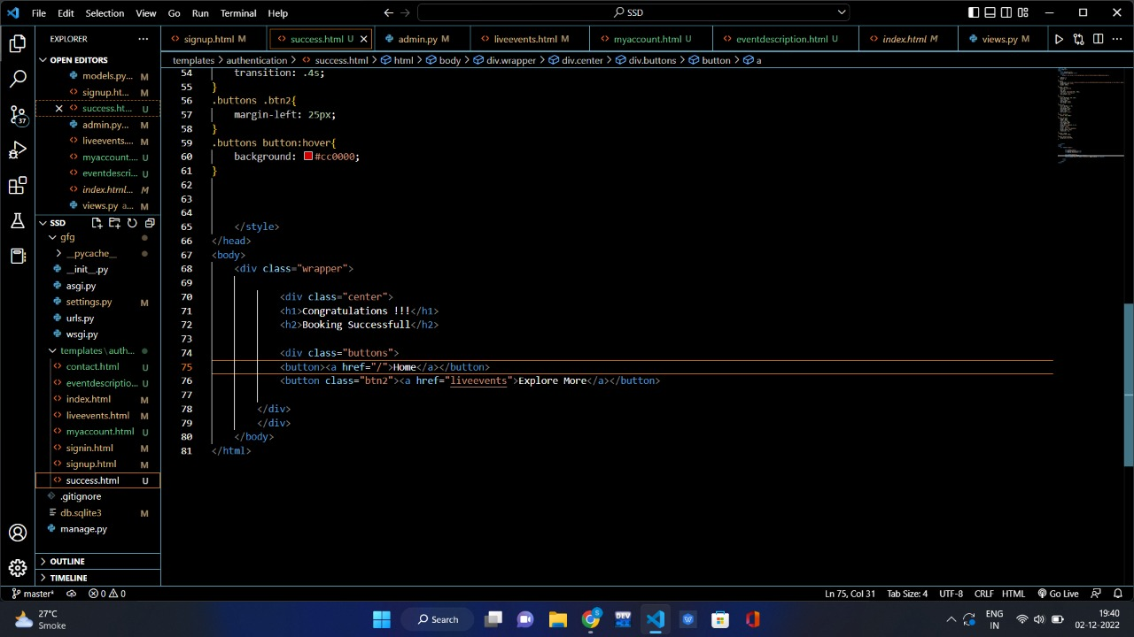

Fig. 5.14 Final Page

Fig. 5.13 Final Page (Source Page)

**Chapter 6: Conclusion**

Event Management System is user friendly and cost-effective system, it is customized with activities related to event management life cycle. It provides a new edge to the management industry. Solution Dot always keep your objectives and goals as a top priority while developing any plan of work. In this project, we tried to effectively introduce the concept of event management systems already existing in society. We then explain the concept of online event management systems which are already present. We describe the proposed system and explain the features implemented by our proposed system. We also give a brief overview of the technologies used during the development of our proposed system. Finally, we illustrate the working of our proposed system. This project can be further reﬁned and extended by introducing new and more innovative features.

**Chapter 7: References**

* 1. “Django Tutorials”, <https://youtube.com/playlist?list=PLsyeobzWxl7r2ukVgTqIQc>
  2. “Debugging” <https://www.stackoverflow.com>
  3. “Django & Web Development Tutorials”, URL - <https://www.geeksforgeeks.com>
  4. “Django Tutorials”, URL - <https://www.wikipedia.com>
  5. “Figma: The collaborative interface design tool”, URL- <https://www.figma.com/>
  6. “Swagger : API documentation and design tool for team” , URL - <https://swagger.io/>
  7. “Docker: Accelerated, Containerized Application Development Tool”, URL - <https://www.docker.com/>
  8. “Source code” URL - <https://github.com/Agartala01/event_booking/tree/master>
  9. <https://drive.google.com/file/d/1kCTkGLT8CaonbLAer5KQphs_bXwmA3kF/view?usp=sharing> “Live demo”